Projects and Pipeline
Annual Report 2025 – chapter 5
Noah Fischer · 26 February 2026

Harrow Bay Offshore Wind (480 MW)
In 2025 we signed the turbine supply agreement with Halden Turbine Systems (30 June) and the contracts for foundations, cables and the installation vessel MV Sea Atlas. The final investment decision followed on 12 February 2026. Offshore construction starts in April 2026; commercial operation is planned for June 2028.
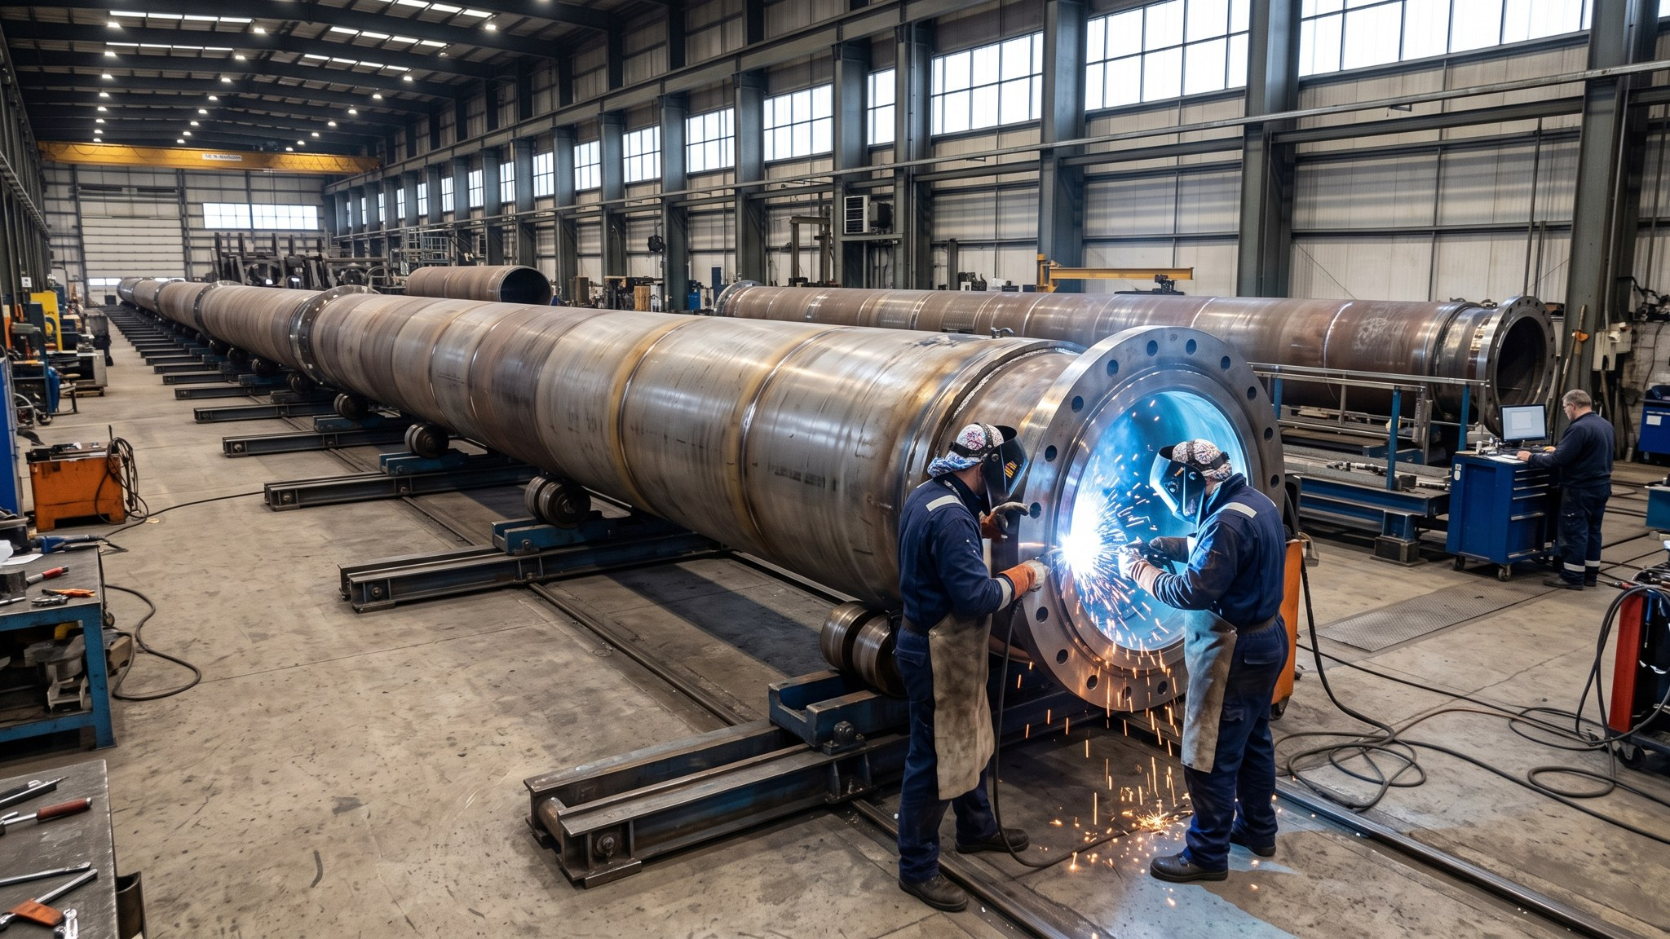
Monopile fabrication for Harrow Bay at Rhenus Steelworks

Millbrook Solar & Storage (85 MWp)
The land lease for 142 hectares north of Millbrook was signed on 18 November 2025. Public consultation starts in March 2026, the planning application is planned for mid-2026.

Further pipeline
- Fenwick Battery Storage (100 MW / 200 MWh) – site secured in principle
- Green Hydrogen Pilot (5 MW) – feasibility study with an industrial partner
- Two North Sea follow-on sites for offshore wind (≈ 1.6 GW)

